Participant Information Sheet
Using sleep and circadian rhythms data in bipolar disorder (AMBIENT-BD)
You are invited to take part in a research study.
To help you decide whether to take part, it is important for you to understand why the research is being done and what it will involve. Please take time to read the following information carefully.
You may talk to others about the study if you wish. Take time to decide whether you wish to take part. Contact us if there is anything that is not clear, or if you would like more information.
If you require this information in an alternative format, such as Large Print, please let us know by contacting us using the details below.

If you have read the Participant Information Sheet and have decided you would like to take part, please get in touch with the research team:
Telephone: 07353103399 or 07353103395
Email: Ambient-bd@ed.ac.uk

What is the purpose of the study?
The purpose of our study is to better understand the impact of sleep patterns on experience of bipolar disorder. Bipolar disorder is a mental illness characterised by extreme mood swings between depression and mania or hypomania. Based on previous literature and our consultations with people with lived experience, we know that sleep disturbances are common among people with bipolar. These disturbances may contribute to the onset of mood episodes. However, most methods of studying sleep have limitations (such as being invasive, resource-intensive, and unable to capture long-term patterns). In this study, we are using innovative technological devices for data collection. This technology has shown promise in monitoring sleep and has advantages over other methods. By studying sleep patterns and clinical symptoms over an 18-month period in 180 people with bipolar disorder, we aim to gain insights into the mechanisms underlying relapse.
Please note: This is an observational study and should not be considered a source of additional care or treatment of any kind. The research team cannot assess you or provide you with any medical diagnosis apart from what you already have. It is important you remain in contact with your GP and clinical care team as normal during the study. Your care will continue to be provided by your GP or clinical care team.

The study is arranged in different parts and collects data using different components.
Screening appointment: A 1-1.5-hour online appointment to determine the eligibility of the participants based on the study inclusion/exclusion criteria.

Baseline study appointment: A 1.5-2-hour in-person appointment at the Clinical Research Facility, Royal Infirmary of Edinburgh to enroll participants onto the study and collect data about day-to-day life. This appointment will also consist of the PIPR test used to test light sensitivity (more information given below).

Subsequent study appointments: Three subsequent appointments for 1-1.5 hours conducted online to get information about your mental health and wellbeing. These appointments will be held at 6, 12 and 18 months after your baseline appointment.
Why have I been invited to take part?
You have been asked to take part as you have a diagnosis of bipolar.

Am I eligible to take part?
To take part in the study you need to be 16 or over, live in the UK and have a smartphone.
You need to be able to read and understand English on a basic level and demonstrate that you understand what is expected of you as a participant in the study.

You can have any bipolar disorder diagnosis (Type 1 or Type 2). You must not have had any episodes of depression, mania or hypomania within 1 month prior to the screening visit.
We also ask that you do not take part in any research assessing new treatments (e.g., trials of new drug or psychotherapy treatments) whilst enrolled on AMBIENT-BD. You will be able to take part in other observational studies.
A member of the research team will discuss the eligibility criteria with you when they get in touch about your potential participation in the study.
Do I have to take part?
No, it is up to you to decide whether to take part. If you do decide to take part, you will be given this information sheet to keep and you will be asked to sign a consent form. You are free to withdraw at any time and without giving a reason. If you decide to withdraw, we will keep records relating to the data that has already been collected (unless you object).
Deciding not to take part or withdrawing from the study will not affect the healthcare that you receive, or your legal rights.
How long do I have to decide to take part?
You are welcome to take your time to decide whether to take part. Please note, however, that we will stop recruiting participants at the end of September 2026.
What will happen if I take part?
What are the enrolment procedures?
You will have contacted the research team to express interest in taking part in the study after which this participant information sheet has been sent to you. After receiving this document, the research team will give you at least 3 days to read it fully. We will aim to contact you after this time to see if you want to take part. You are welcome to contact the research team yourself at any time using the contact information on the last page of this information sheet. Once you have read the information sheet and if you are still interested
in participating in the study, we will arrange your first study appointment (screening

appointment). Study appointments take place on certain days of the week and the research team will work with you to try and ensure your participation suits your schedule.

When and where do the study appointments take place?

There are five study appointments in total. Details of the appointments are as follows:

Initial screening appointment (remote- phone/online)
A member of the research team will conduct this appointment to determine your eligibility to take part in the study. This appointment will be via videocall conducted using NearMe (an NHS approved online software). If you prefer, we can conduct the visit over the telephone. Firstly, we will ask for your verbal consent to complete a screening questionnaire. A member of the study team will complete a verbal consent form and a copy of this form will be sent to you after the appointment. The researcher will then go through a screening questionnaire with you, which will focus on your history of bipolar. This should take 1-1.5 hours. If you are not eligible or if you decide not to take part, we will not keep this data. But if you are eligible and still want to take part, we will then arrange a baseline appointment.

Baseline appointment (in-person)
Your baseline appointment will take place in-person at the Clinical Research Facility, Royal Infirmary of Edinburgh. It will last approximately 1.5-2 hours. Reasonable travel and accommodation costs will be reimbursed by the study team so that you can attend in person. Before we start any study activities, we will ask you to sign a consent form. A member of the research team will go over the form with you and answer any questions you might have. A copy of this form will be provided to you. Then, we will ask you some questions about lifestyle, sleep and mental health. You will be asked to answer some potentially sensitive questions about your childhood experiences, psychiatric history and drug use in the presence of the researchers. We will also be conducting a brief eye test at the Clinical Research Facility. This test is called PIPR (Post-Illumination Pupillary Response), which will measure the size of your pupils in response to light. It is a straightforward test that tell us how sensitive you are to light, which we are interested in as it might be an important factor in bipolar. To measure PIPR, we will use apparatus similar to that used during optician eye tests. Different coloured lights will be shone into one eye and the response of your pupils will be measured. We ask that you keep your head still and eyes open during this test, which will take around 15 minutes in total. Finally, at this appointment, we will also give you the digital devices that you will use throughout the study at this appointment. Once the appointment is completed, a

letter will be sent to your GP and psychiatrist (if you have one), to inform them of your participation in the study.

Follow-up appointments (remote- phone/online)
At 6 months, 12 months and 18 months, you will have follow-up appointments. These will be online using NearMe (or over the phone if you prefer) and will last approximately 1-1.5 hours. During these appointments, we will check if you have had any episodes of depression or hypomania/mania in the preceding 6 months, and we will ask about any changes in your medication or recent stressful events.
For attending these appointments, you will be offered £15 for each study appointment, which can be paid either by bank transfer or voucher. You will therefore be offered a total of £75 for attendance to all five study visits. You will also be reimbursed for reasonable travel, and accommodation costs up to £300.

Ambient/passive data collection

Below is more information about the devices that you will be using throughout your time on the study:

Bedside sensor (Somnofy):
We will give you a bedside sensor that monitors movement and your bedroom environment. This will be with you for the whole 18 months. The sensor records conditions of sleep like movement, room temperature, sound level, and light. It uses radar to see when you awake or asleep, but it cannot see what you are doing. It does not record voices or sounds. It is also helpful to mention the device does not record any audio or video or any other personal information. It is non-invasive and works according to the breathing patterns of the person it is directed towards (in this case you). You are encouraged to carry on your routine activities to ensure naturalistic data collection. The sensor sends this data to a cloud platform through the internet, but you will not be able to access it.
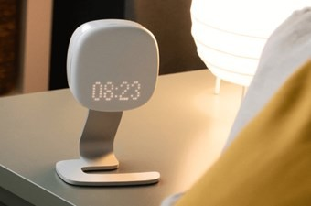
It is unobtrusive and does not make any noise. If you go away overnight or on holiday, we will ask you to take the sensor with you if you can. You will be provided written instructions on how to set up the devices. Please note that these Somnofy devices can be used in shared sleep environment or if you have pets or children. You will be provided detailed instructions on the setting up the devices at your baseline appointments.

Activity monitoring watch (Axivity):
You will also get a wrist-watch activity monitor (similar to a FitBit) to wear for 9 weeks at four different time points during the study. It will keep track of your movement and light exposure throughout the day and night. You will need to take it off for showering or swimming and put it back on afterward.
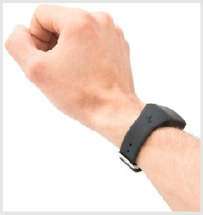

Smartphone assessments:
We will ask you to complete questionnaires about your mood on your smartphone for a 1-week period every four months. This is called a “burst EMA” (ecological momentary assessment). EMA is used as a way of getting real-time information about your mood and wellbeing. The questions we ask you will be about how you feel at that moment, rather than how you felt in the past. We will ask you to complete the questionnaires 4 to 8 times per day, for seven days. These will be short questionnaires and will take no more than 1 minute to complete each time. You will receive reminders at random times throughout the day. You’ll also be asked to complete one sleep diary entry per day.
More information about the timings of appointments and the EMAs is shown in the diagram below:

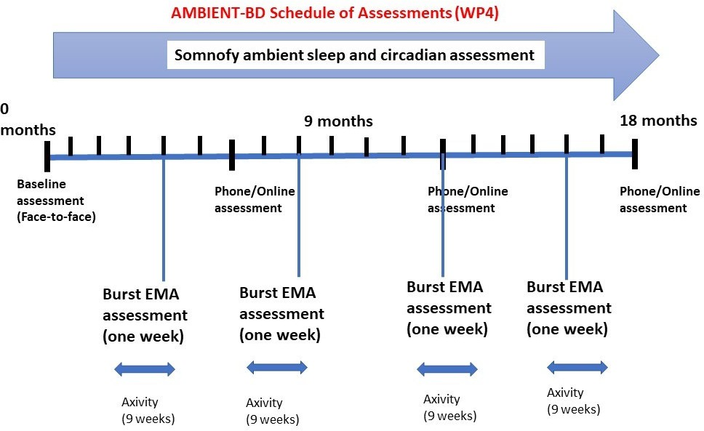
What are the possible benefits of taking part?
There are no direct benefits to taking part in this study. However, it is possible that the results from this study may be beneficial to other people with bipolar disorder in the future and your participation could make a meaningful impact on this important area of research.

At the end of the study, you will be offered a summarised report on your sleep and activity patterns, which might assist you in monitoring your future behaviour.
What are the possible disadvantages of taking part?
You may find the study time consuming as you will be in the study for 18 months in total. However, the Somnofy sleep device that will be used for this time collects data passively and so after it is set up you will not be required to do anything else with it. You might require setting it up again in case you take the device with you on holiday.
You are required to attend four 6-monthly appointments over a period of 18 months, each approximately 1-2 hours. These appointments will include multiple questionnaires that may take some time and ask questions about your personal and mental health history. You will be asked to answer some potentially sensitive questions about your childhood experiences, psychiatric history and drug use. It is important that if you find any of the questions

distressing, you discuss this with the research team. They will be able to support you and, if
necessary, advise you on the best way for you to seek further help.

There is a small possibility that you may experience some skin irritation from the watch strap. If this happens, please remove the watch immediately.

When measuring the pupil and how it reacts to light, there is a small possibility that an abnormality affecting the eye could be found. If this occurs, you will be informed of the finding and we will ask for your permission to inform your GP so that further tests can be completed.
You may have some privacy concerns about your data, but we have carefully selected storage locations that are secure and have limited access to only essential staff (more information on confidentiality is given below).
What if there are any problems?
If you have any concerns about the study, you can initially contact the AMBIENT-BD research team at Ambient-BD@ed.ac.uk. If you have a concern about any aspect of this study please contact Professor Daniel Smith, Chief Investigator at D.Smith@ed.ac.uk who will do their best to answer your questions.
What will happen if I don’t want to carry on with the study?
You are free to withdraw from this study at any stage. All non-identifiable data collected up until the point of withdrawal will be retained and used, unless you specifically request for us to not use your data. Identifiable data will be retained for administrative purposes until the study has concluded. If you wish to stop taking part during the appointments, you can mention this to the researcher at your appointment. If you wish to stop taking part during the data collection, you can simply unplug the devices and remove the watch, and no more data will be collected. Please then return the devices in pre-paid packaging.

If you wish to withdraw your data from further analysis, you can do so by emailing the research team on Ambient-BD@ed.ac.uk. Please state that you want your data to be removed from further analysis. It is important to note that at one year from the end of the study, the key that links the unique identifiers to the scientific data will be deleted making data completely anonymous and no longer possible to identify your data. Therefore, your
data cannot be removed after this time point.

What happens if I become unwell during the study period?
Please inform the study team if you are feeling unwell during the study period. The study
team can help you to seek support from your GP or clinical care team if required. It is important you remain in contact with your GP and clinical care team as normal during the study as your care will continue to be provided by them.
As with all research, it is important that you are well enough to be able to give your consent to take part in this study. This is called having “capacity” to consent and it relies on an individual being able to understand the study and what is expected of them. It is important to note that on rare occasions, an individual may become so unwell that they lose capacity to consent. For example, a participant may lose the capacity to give consent whilst experiencing severe psychosis leading to detention under the Mental Health Act. In these situations, it would not be right to continue in the study as the participant would not be able to give their informed consent.
It is possible that following the resolution of such an episode, capacity to consent will be regained. In this case, participants will be offered a rescheduled appointment with the researcher and they would be able to continue participation, including collection of sleep data through Somnofy devices.

Once you have given your consent at the baseline appointment, it will be assumed to be valid until your next appointment for the purposes of using the Somnofy devices. This is because contact between you and the study team will be limited between the appointments to ensure the data being collected is as true to life as possible. At every study appointment, we will check that you are still willing and able to give your consent to take part.

Wherever the withdrawal of a participant from the study is necessary due to a loss of capacity to consent, data collected up to the point of withdrawal will be retained and would be used in future analyses, unless you request otherwise.
What happens when the study is finished?
Identifiable data (e.g., name, date of birth, address, post code, email address) including the
ID-key, will be deleted at one year from the end of the study, making all data anonymous from this date.

Non-identifiable data (e.g., sleep and activity data) will be kept for fifteen years on the
University of Edinburgh’s secure servers for administrative and analytic purposes. During the consent procedure we ask permission to store your data for future use in ethically approved research studies. This means that anonymised data can be requested for analysis by other researchers.
VitalThings (the company who make the Somnofy sleep devices) will retain the anonymous sleep data indefinitely on their cloud platform. Oculox Technologies (who manufacture the PIPR eye examination device) will retain pseudonymous data on their RetinaWISE software. The data will be shared as a part of the access to the respective cloud portals and the individual companies will not be able to identify individual participants. Each participant will be assigned a participant ID, the key to which will not be available to anyone outside the research team. All data analysis for the purpose of AMBIENT-BD will be conducted by the research team at the University of Edinburgh.
Will my taking part be kept confidential?
All the information we collect during the course of the research will be kept confidential and there are strict laws (including the UK GDPR and Data Protection Act 2018) which safeguard your privacy at every stage.
How will we use information about you?
We will need to use information from you for this research project.
The Clinical Research Facility requires you provide your CHI number (for those living in Scotland) or NHS number (the rest of UK) to register you on TRAK, an electronic health record system. This is so information about your participation in the study can be documented and will not be used to review previous health records.

Other personal identifiable information collected will include your:
- Initials
- Name
- Date of birth
- Ethnicity
- Sex

- Address & postcode
- Telephone number
- E-mail address

The research team need this information to keep in contact with you and to properly conduct the study.
We will keep all information about you safe and secure within the University of Edinburgh and on secure research databases. All research data is password-protected and accessible only by the research team. University of Edinburgh policy regarding data management will be followed at all times (https://www.ed.ac.uk/information-services/about/policies-and- regulations/research-data-policy).
It is possible that our study may be inspected by our joint sponsor (University of Edinburgh and NHS Lothian) or regulatory authorities during the study. This will mean that members of these organisations may need to access your research data. This is a common and important process in clinical research and makes sure that studies are being conducted correctly. These organisations will abide by strict confidentiality rules, and they will not share your personal information with anyone.

After the end of the study, your data will be anonymised and shared as part of the wider dataset via Open Science Framework (OSF,osf.io), which follows good research practice. Publishing anonymised datasets is increasingly common in science research. It improves accessibility to research and replicability of results. You will need to consent to the publication of your anonymised data to participate in this study.

If you consent, your contact details may be used to be contacted about other ethically approved research studies for which you may be suitable. Your contact details will be stored in a separate password-protected location on the University of Edinburgh DataStore. Only essential researchers will be granted access. Your consent may be sought to pass your contact details to other researchers within the University of Edinburgh, so that you can be informed of future studies for which you may be eligible. Agreeing to be contacted does not oblige you to participate in further studies. Contact details will be stored until the end of the study or up to 5 years if you give your consent for future contact.

Some of your information like year of birth, sex, height and weight will be entered on Somnofy’s and RetinaWISE’s Research Platform that VitalThings and Oculox, respectively will have access to. There have been data collaboration agreements between the University and sub-contractors that clearly state that the transfer of data will be relevant for this specific study only. Pseudonymised means that we use participant codes or ID to link your data, to

avoid using your personal information throughout the data analysis process. Furthermore,
you will not be identified by any of our reports, conference presentations or any knowledge disseminated from this study.
How do we manage your data?

During the study, your contact details will be stored in a secure password protected location with limited access to the research team. A code, linked to your name will be randomly generated, which will be used during the data collection. All documents containing identifiable information will be stored in a separate location, with access limited to the research team.
VitalThings (Somnofy) will have access to the sleep data but they will not have access to the key linking to the coded identifiers, so it will not be possible for them to identify participants. Oculox Technologies (manufacturers of the PIPR examination device) will have access to your pupil measurement data, but will not be able to identify you from the data as it will also be linked to a unique identifier. At the end of participation in the study, all data will be downloaded and securely stored in the University of Edinburgh’s DataStore, under password-protection. DataStore is the university compliant data management software.

How will the data be collected and what will it contain?

REDCap (Research Data Capture) is a web application that is commonly used in clinical research. It is one of the platforms adopted by the University of Edinburgh and is compliant with the GDPR. It will be used to collect data from you including consent forms and questionnaire answers.
What are your choices about how your information is used?
You can stop being part of the study at any time, without giving a reason, but we will keep information about you that we already have, unless specifically requested otherwise.
We need to manage your records in specific ways for the research to be reliable. This means
that we won’t be able to let you see or change the data we hold about you.
If you agree to participate, you will be given the option to decide whether you would like to be contacted by other teams undertaking research on a similar topic in the future. Agreeing to this is not a requirement of your participation to AMBIENT-BD.

Where can you find out more about how your information is used?
You can find out more about how we use your information:
- At www.hra.nhs.uk/information-about-patients/
- Our leaflet available from www.hra.nhs.uk/patientdataandresearch
- By asking one of the research team members
- By contacting us on 07353103399 or 07353103395 or Ambient-BD@ed.ac.uk
What will happen to the results of the study?
When the study is finished, we will provide all study participants with a results letter
containing a summary of the study’s findings. This study will be written up for publication in scientific journals and presented at conferences. You will not be identifiable from any published results.

Study updates and results will also be made available via the following:
- On the AMBIENT-BD website (https://www.ambientbd.com)
- On the Bipolar Scotland website (https://www.bipolarscotland.org.uk) and in their newsletters.
Who is organising and funding the research?
This study has been organised by the AMBIENT-BD research team and is jointly sponsored by the University of Edinburgh and NHS Lothian. The study is funded by The Wellcome Trust.
Who has reviewed the study?
All research in the NHS is looked at by an independent group of people called a Research Ethics Committee. A favourable ethical opinion has been obtained from East of Scotland Research Ethics Service. NHS Management Approval has also been given. NHS management approval has also been obtained. The study proposal has been reviewed by The Wellcome Trust.

This study has been co-produced with people with lived experience of bipolar disorder. They have reviewed the study design and protocol and gave their input on the clinical and functional outcomes to be used in this study. The AMBIENT-BD Lived Experience Advisory Panel (LEAP; separate from co-producers) have also informed the study design by giving
feedback on the initial project proposal.

How can I sign up to take part?
If you would like to take part in the study after reading this leaflet, please contact the study team by emailing AMBIENT-BD at Ambient-BD@ed.ac.uk or calling 07353103399 or 07353103395 to arrange an initial screening appointment.
Researcher Contact Details
If you have any further questions about the study, please contact the research team at Ambient-BD@ed.ac.uk.
Independent Contact Details
If you would like to discuss this study with someone independent of the study please contact Stephen Lawrie, Professor of Psychiatry and Consultant Psychiatrist at S.Lawrie@ed.ac.uk.
Complaints
If you wish to make a complaint about the study please contact:
Patient Experience Team – NHS Lothian
Mainpoint
102 Westport
Edinburgh
EH3 9DN
By telephone
0131 536 3370 (open Mon-Fri, 9am to 2pm)
By email
LOTH.Feedback@nhs.scot

